Delta Drive Bulletin & Pulpit Announcements

My worthy Brother Knights, please put these techniques into your communication plans. Use these templates for bulletin and pulpit announcements to enhance your message.
How should they be used? Follow these steps for your communication plan.
- Two weeks prior to your membership drive publish an announcement in your church bulletin.
- On the weekend of your drive have pulpit announcements read by a Brother Knight or your Priest.
- Have your recruiting team ready with their elevator speeches and resources to invite the catholic men of your parish to become Knights.
- Follow up with all you new e-members and prospects by inviting them to participate in a program or attend your next Charity/Unity/Fraternity Exemplification.
- Remember to thank Father in a bulletin announcement the following week and invite men to join in that same article.
- Ask for help from your Field Agent, General Agent, Diocesan Membership Director and District Deputy at all your membership events.

Bulletin Announcement for Delta Drive:
The Knights of Columbus is an international Order of Catholic men who are called to lead with faith, protect our families, serve others and defend values in a busy changing world. Our local council ________#_____ will be holding a membership drive at (all Masses) the of (dates). Whether you become an individual member or a member of our council you will find that Knights of Columbus membership brings Catholic men together in a powerful way. If you would like to join today simply go to KofC.org/joinus and enter our council #_____ for local information.
Sample Endorsement from Priests:
I’d like to take a moment to encourage the men of our parish to consider joining the Knights of Columbus and here are a few reasons why.
The Knights of Columbus mission is the empowerment of Catholic men to live their faith at home, in their parish, at work and in their community.
Membership in this fraternal organization will give you the opportunity to give back to your community, exclusive access to fraternal benefits, and the ability to grow in your faith.
The Knights of Columbus is a great source of volunteers for our parish and you have probably seen them in action at our parish events.
I believe that each man in this parish can benefit from membership in this fine group.
Following Mass there will be members of ________________ Council at the church exits.
Please take the time to speak with them, learn more about this wonderful organization and become a member.
God Bless.
Pulpit Announcement, Read by a Council Member:
Through our international Order of Catholic men, we are called to lead with faith, protect our families, serve others and defend our catholic Christian values in this busy changing world. Empowering Catholic Men is our Mission.
Membership in this fraternal organization will give you the opportunity to give back to your community, exclusive access to fraternal benefits, and the ability to grow in your faith.
My Brother Knights of Council #### have been a great source of volunteers at parish events. By becoming a Knight you to can put your faith into action and help us continue our service to this parish.
The best way to join is at kofc.org/joinus and become an online member. You can also meet with my Brother Knights after mass to gain more information about our council.
Thank you.
Pulpit Announcement, Read by a Council Member - Empowering Catholic Men
The Knights of Columbus is an international Order of Catholic men who are called to lead with faith, protect our families, serve others and defend values in a busy changing world. Through the empowerment of the catholic men in council #### our Brother Knights have changed lives and saved lives.
Our council activities allow us to bring our Faith into Actions. Council #### seeks to strengthen our efforts through the addition of new Brother Knights. We want them to experience the empowerment to live their faith at home, in their parish, at work and in their community.
If you would like to join today simply go to KofC.org/joinus and enter our council #_____ for local information. Or you can meet one on one with my Brother Knights in the back of church after this mass.
Thank you.
Post Drive Bulletin Announcement:
My Brother Knights and I want to thank Fr. (Name) for allowing our council ####, to host a membership drive last weekend. If you don’t know, the Knights of Columbus is an international Order of Catholic men who are called to lead with faith, protect our families, serve others and defend values in a busy changing world.
If you missed our membership drive, you can still join. Whether you become an individual member or a member of our council you will find that Knights of Columbus membership brings Catholic men together in a powerful way. If you would like to join today simply go to KofC.org/joinus and enter our council #_____ for local information.
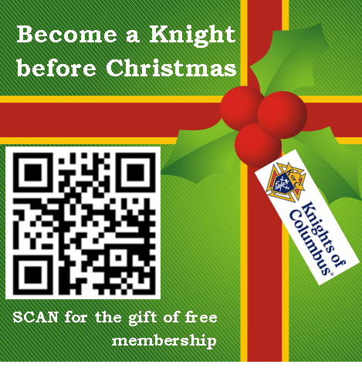
Thank you.
I hope this helps you and good luck with your growth efforts.
Dan Fuller, State Membership Director

